

**Company Overview**

Scancell is a clinical stage immunotherapy company with a revolutionary ImmunoBody® vaccine platform for cancer and chronic infectious diseases. The Company has two products,SCIB1, a DNA vaccine in Phase II clinical trials for the treatment of melanoma, and SCIB2 which targets lung and other cancers and is currently delivering positive results from animal studies

Scancell was founded in 1997 out of Nottingham University, listed on PLUS in 2008 and moved to AIM in the Summer of 2010.

**Headquarters:**Department of Clinical Oncology  
City Hospital  
Hucknall Road  
Nottingham  
NG5 1PB

**Phone:** 0207 653 9841

Web Address:  
[www.scancell.co.uk](http://www.scancell.co.uk)

**Share Symbol:**SCLP

Share Price:

7.13p

Market Cap:

£13.9m

**Group Founded:**1997

**IPO:**September 2008

**Move to AIM:**July 2010

**Fiscal Year End:**April

**Major Shareholders:**

Calculus Capital  
13%  
New Edge Group SA  
9.04%  
Directors  
8.81%  
Hygea VCT plc  
4.29%  
JG Helfinstein  
5.38%  
Oxford Technology VCT plc  
4.29%  
Share Nominees Ltd  
3.48%  
T Walthie  
3.2%

**Company Update**

•Raised £1.73 million in June 2011

•Received milestone payment of £2.85m from Cephalon (previously Arana) when SC104 entered clinical trials in the US in November 2011, confirming the commercial value of Scancell science.

•Funds ensure the Company can complete proof of concept clinical trials of for SCIB1 .

•Progress for SCIB1 phase 1 trial,

-Patient recruitment has been completed

-Dose escalation has reached its highest point of 4mg with no serious adverse effects

•Scancell is expecting to produce data from phase I clinical trials in 2012, followed by results from phase II in 2013. SCIB2 has also produced positive results in its animal studies.

•Changes have been made to the Board structure as Dr Richard Goodfellow has become joint CEO with Professor Lindy Durrant and Kate Cornish-Bowden joins as a Non-Executive Director.

• Partnerships with Ichor Medical Systems, immatics Biotechnologies GmBH and others to optimise immune response and generate new products continue to be productive

**The Market**

There are 12.7 million new cases of cancer being reported globally a year and this figure is expected to rise to 26million by 2030. Within this figure 7.2 million of these cases are being diagnosed in the developing world. With this growth in cancer cases, the global oncology market has expanded at a CAGR of 12.3%. In 2010, worldwide sales of cancer treatment products reached £34 billion.

2011 saw the return in M&A deal value, Amgen paid up to $1 billion in its acquisition of Biovex. Large biotech firms are also becoming increasingly aggressive in their acquisition of innovative companies which will add value and increase competitiveness in the market. Partnership deals have increased as large pharmaceutical companies move away from conducting their Research & Development in house and further rely on collaboration with Industry and Academia.



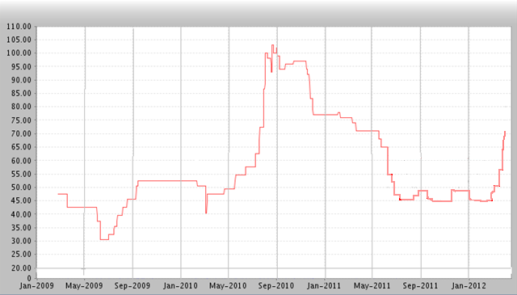

Scancell’s Market Cap Jan 1st 2008-2012

Scancell’s Share Price 2009-2012



**Products:**

***ImmunoBody® vaccines – for effective cell mediated immunity***

**SCIB1- is a melanoma vaccine incorporating 2 melanoma specific T-cell epitopes.  
  
SCIB2- is a therapeutic vaccine targeting NY-ESO-1 that will have potential for the treatment of a range of cancerss, including lung, oesophageal, prostate, liver, gastric, ovarian, and bladder cancer .**

This unique and patented vaccine technology overcomes the present limitations of many therapeutic vaccines. In essence, an ImmunoBody® is a human antibody that acts as a vector that can deliver information about a foreign agent or pathogen (this might be a tumour or an infecting agent) to dendritic cells. Dendritic cells use this information to activate an immunological cascade resulting in the production of helper and cytotoxic T-cells directed against the target of interest (i.e. the tumour or the infecting agent). This is termed ‘cellular immunity’, which alongside antibody production (known as ‘humoral immunity’), forms the basis of the body’s immune defence system. Although it is relatively easy to produce a humoral immune response with a vaccine, the holy grail for many years has been to find a way of producing a complete cellular immune response (involving the stimulation of both helper and cytotoxic T-cells). The ImmunoBody® technology addresses this issue.

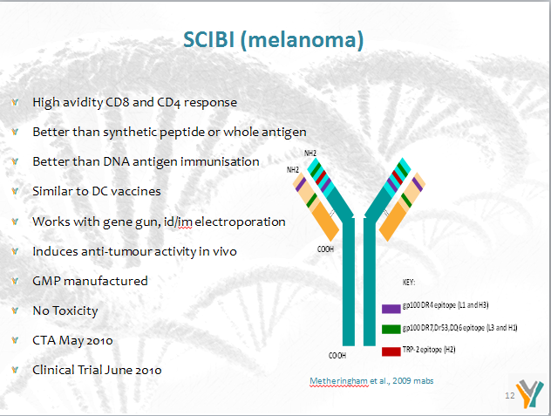

**A Board Member**

**Kate Cornish-Bowden (Non-executive Director)**A Chartered Financial Analyst, Kate was managing director and head of Morgan Stanley Investment Management’s Global Core Equity Team between 2002 and 2004. More recently, Kate has acted as a consultant providing financial research to private equity and financial training firms and was appointed a director of Investec Structured Products Calculus VCT plc in February 2011.

**Patent Win**

Scancell’s protein ImmunoBody® patent has recently been approved in the United States. The patent, which has already been approved in Europe and Australia, will further strengthen Scancell’s IP position around its proprietary ImmunoBody vaccine platform.

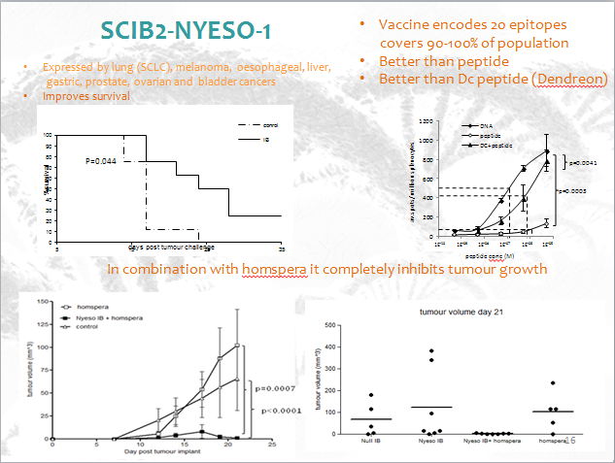

Advisors Contact:

Zeus Capital, NOMAD and Joint Broker  
0161 831 1512

XCAP Group, Joint Broker  
0207 101 7070

Newgate Threadneedle, Financial PR  
0207 653 9850